IBM Business Automation Manager Open Editions

Getting started with IBM Business Automation Manager Open Editions (IBAMOE v9.5.2)

October 2026
Latest Version: https://ibm.box.com/v/IBM-BAMOE-TZ-ENV

Raul Mariano: raul.mariano@ibm.com
Paul Pacholski: pacholsk@ca.ibm.com

NOTICES
This information was developed for products and services offered in the USA.
IBM may not offer the products, services, or features discussed in this document in other countries. Consult your local IBM representative for information on the products and services currently available in your area. Any reference to an IBM product, program, or service is not intended to state or imply that only that IBM product, program, or service may be used. Any functionally equivalent product, program, or service that does not infringe any IBM intellectual property right may be used instead. However, it is the user's responsibility to evaluate and verify the operation of any non-IBM product, program, or service.
IBM may have patents or pending patent applications covering subject matter described in this document. The furnishing of this document does not grant you any license to these patents. You can send license inquiries, in writing, to:
IBM Director of Licensing
IBM Corporation
North Castle Drive, MD-NC119
Armonk, NY 10504-1785
United States of America
The following paragraph does not apply to the United Kingdom or any other country where such provisions are inconsistent with local law: INTERNATIONAL BUSINESS MACHINES CORPORATION PROVIDES THIS PUBLICATION "AS IS" WITHOUT WARRANTY OF ANY KIND, EITHER EXPRESS OR IMPLIED, INCLUDING, BUT NOT LIMITED TO, THE IMPLIED WARRANTIES OF NON-INFRINGEMENT, MERCHANTABILITY OR FITNESS FOR A PARTICULAR PURPOSE. Some states do not allow disclaimer of express or implied warranties in certain transactions, therefore, this statement may not apply to you.
This information could include technical inaccuracies or typographical errors. Changes are periodically made to the information herein; these changes will be incorporated in new editions of the publication. IBM may make improvements and/or changes in the product(s) and/or the program(s) described in this publication at any time without notice.
Any references in this information to non-IBM websites are provided for convenience only and do not in any manner serve as an endorsement of those websites. The materials at those websites are not part of the materials for this IBM product and use of those websites is at your own risk.
IBM may use or distribute any of the information you supply in any way it believes appropriate without incurring any obligation to you.
Information concerning non-IBM products was obtained from the suppliers of those products, their published announcements or other publicly available sources. IBM has not tested those products and cannot confirm the accuracy of performance, compatibility or any other claims related to non-IBM products. Questions on the capabilities of non-IBM products should be addressed to the suppliers of those products.
This information contains examples of data and reports used in daily business operations. To illustrate them as completely as possible, the examples include the names of individuals, companies, brands, and products. All of these names are fictitious and any similarity to the names and addresses used by an actual business enterprise is entirely coincidental.
TRADEMARKS
IBM, the IBM logo, and ibm.com are trademarks or registered trademarks of International Business Machines Corp., registered in many jurisdictions worldwide. Other product and service names might be trademarks of IBM or other companies. A current list of IBM trademarks is available on the web at “Copyright and trademark information” at www.ibm.com/legal/copytrade.shtml.
Adobe, the Adobe logo, PostScript, and the PostScript logo are either registered trademarks or trademarks of Adobe Systems Incorporated in the United States, and/or other countries.
Cell Broadband Engine is a trademark of Sony Computer Entertainment, Inc. in the United States, other countries, or both and is used under license therefrom.
Intel, Intel logo, Intel Inside, Intel Inside logo, Intel Centrino, Intel Centrino logo, Celeron, Intel Xeon, Intel SpeedStep, Itanium, and Pentium are trademarks or registered trademarks of Intel Corporation or its subsidiaries in the United States and other countries.
IT Infrastructure Library is a Registered Trade Mark of AXELOS Limited.
ITIL is a Registered Trade Mark of AXELOS Limited.
Java and all Java-based trademarks and logos are trademarks or registered trademarks of Oracle and/or its affiliates.
Linear Tape-Open, LTO, the LTO Logo, Ultrium, and the Ultrium logo are trademarks of HP, IBM Corp. and Quantum in the U.S. and other countries.
Linux is a registered trademark of Linus Torvalds in the United States, other countries, or both.
Microsoft, Windows, Windows NT, and the Windows logo are trademarks of Microsoft Corporation in the United States, other countries, or both.
UNIX is a registered trademark of The Open Group in the United States and other countries.
© Copyright International Business Machines Corporation 2026.
This document may not be reproduced in whole or in part without the prior written permission of IBM.
US Government Users Restricted Rights - Use, duplication or disclosure restricted by GSA ADP Schedule Contract with IBM Corp.

Table of Contents

1 Accessing the Tech Zone Environment 4
1.1 Reserve the Environment in the IBM Tech Zone 4
1.2 Windows 11 – User IDs and Passwords 4
2 Workaround: Podman containers are not running! 5
3 About the environment 6
3.1 How do I access the applications? 8
4 Consult Documentation and Communities 9

Accessing the Tech Zone Environment

Reserve the Environment in the IBM Tech Zone

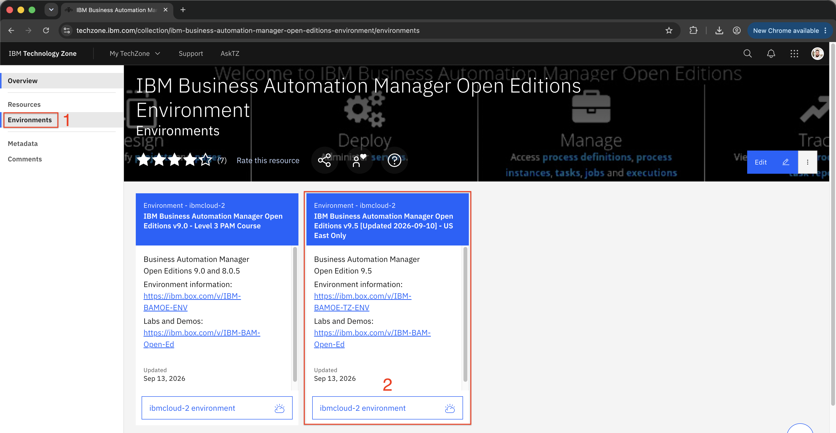

Item | Description
0 | Navigate to IBM Tech Zone Collection
1 | In the side menu, click on "Environments"
2 | See which spaces are available and click the button to reserve them.
3 | Follow the instructions to create a reservation
4 | After submitting your request, you will receive an email with the status of your environment. Wait for the notification that your environment is Ready.

Windows 11 – User IDs and Passwords

User: techzone
Password: IBMDem0s!

Workaround: Podman containers are not running!

We identified that a WSL v3.0.1 update on September 29th impacted the execution of Podman containers. After several attempts, we found a workaround and rolled back the WSL version. So, if you encounter this issue, please run this script:

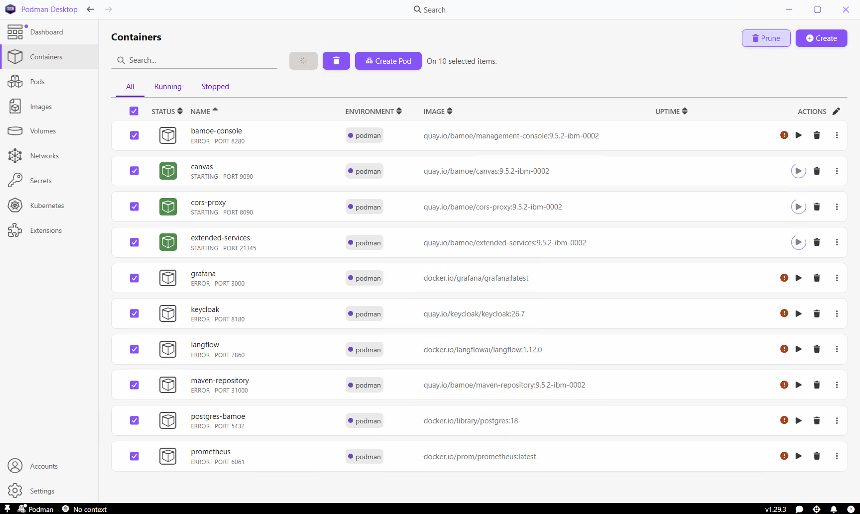

- Open PowerShell as an administrator.
- You can run the commands all at once:

Stop-Service -Name "wuauserv" -Force; Set-Service -Name "wuauserv" -StartupType Disabled
wsl --version
Stop-Process -Name "Podman Desktop" -Force
winget uninstall --id Microsoft.WSL --source winget --exact
winget install --id Microsoft.WSL --version 2.5.10 --source winget --exact
wsl --version
$configPath = "$env:APPDATA\containers\containers.conf.d\99-firewall.conf"
Set-Content -Path $configPath -Value "[network]`nfirewall_driver =`"none`""
podman machine stop
podman machine start
podman start –all
$pause = (Get-Date).AddDays(35); $pause = $pause.ToUniversalTime().ToString( "yyyy-MM-ddTHH:mm:ssZ" ); Set-ItemProperty -Path 'HKLM:\SOFTWARE\Microsoft\WindowsUpdate\UX\Settings' -Name 'PauseUpdatesExpiryTime' -Value $pause
- Next, open Podman Desktop, and the containers should be running.

About the environment
This environment was built based on the official product documentation, so be sure to check it out for more information about the new BAMOE Version 9.5.x

We will be updating this environment with new materials and resources as often as possible.

We aim to consolidate all BAMOE applications and other components running in Podman containers. For this reason, I recommend opening Podman Desktop (the icon located on the desktop) 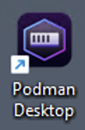 and checking:
- In the Podman settings, ensure that the Podman Machine is "RUNNING".

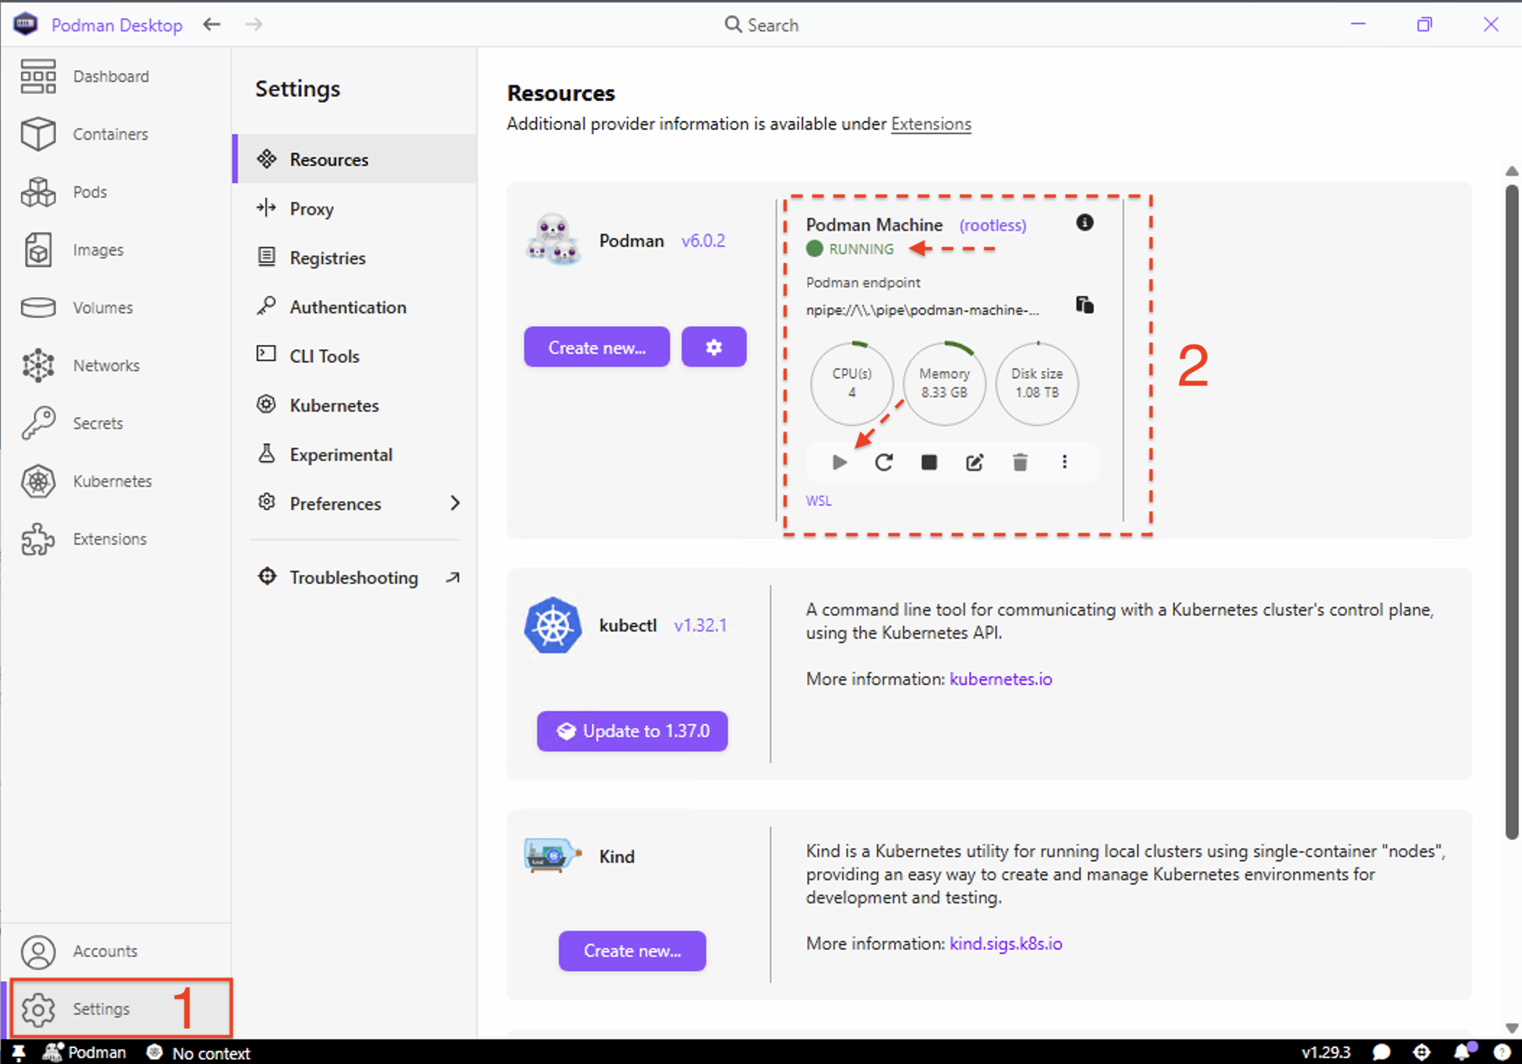

- With Podman Machine running, select and run all containers

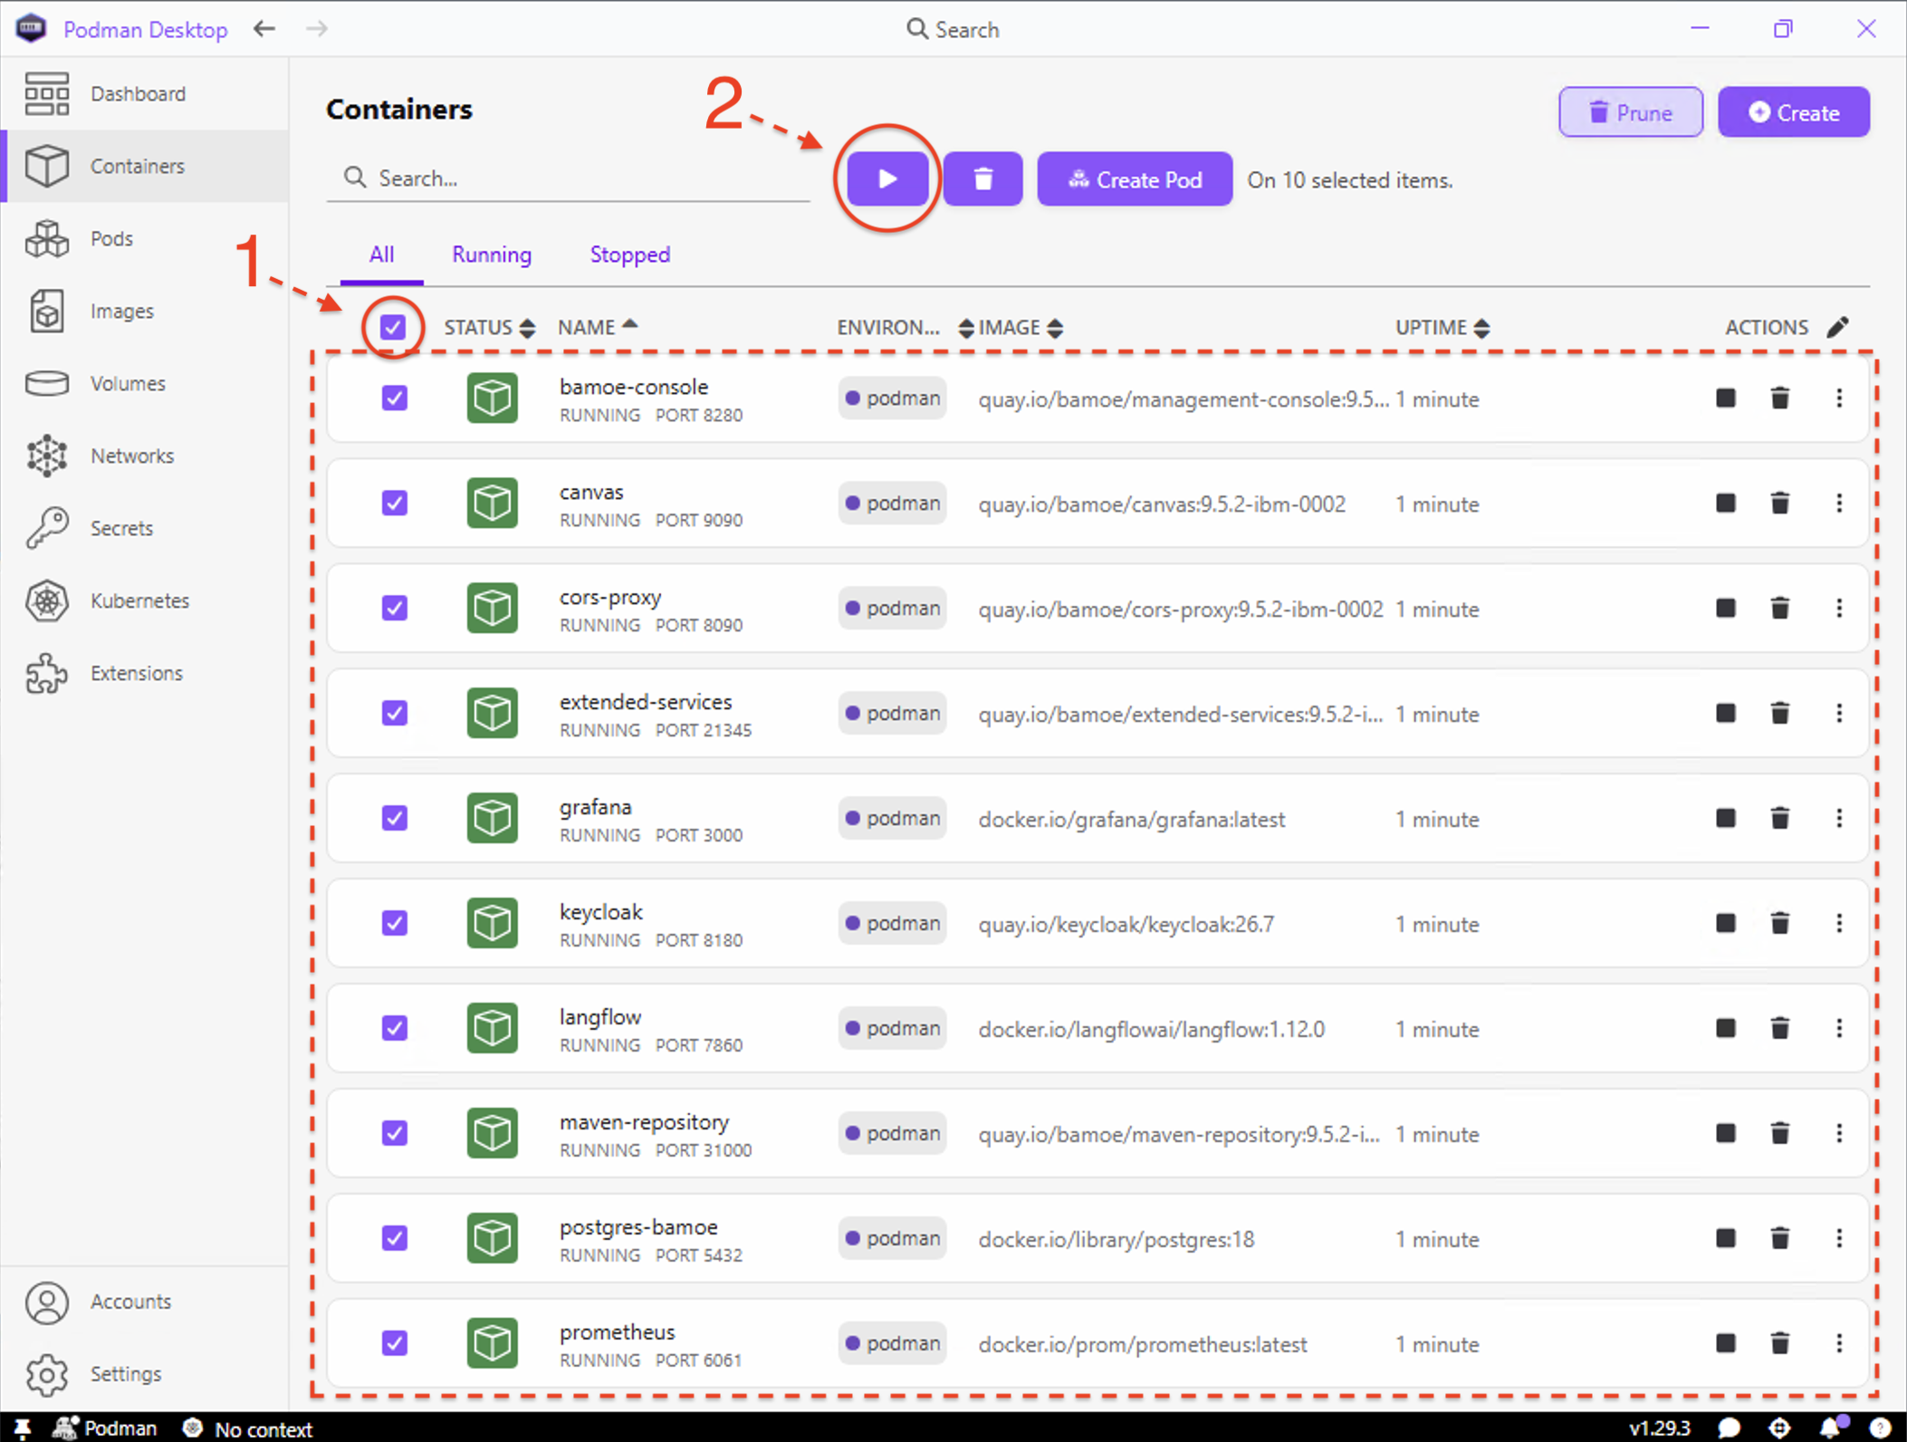

In addition to containers, you can use Ollama to test BAMOE's AI capabilities. To do so, run it by clicking the executable on your desktop 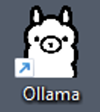.

How do I access the applications?

Use the Google Chrome browser to access the applications, we have already saved the URL and access details for each one in the Bookmarks List:

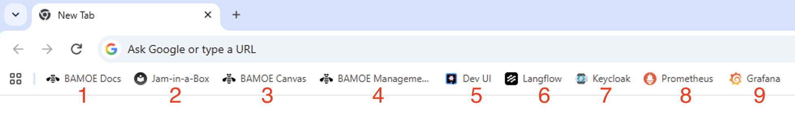

Item | URL | Username and Password
BAMOE Docs | https://www.ibm.com/docs/en/ibamoe | NODE
Jam-in-a-Box | https://ibm.github.io/cp4ba-jam-in-a-box/BAMOE/ | NODE
BAMOE Canvas | http://localhost:9090 | NODE
BAMOE Management Console | http://localhost:8280 | NODE
Dev UI | http://localhost:8080/q/dev-ui | NODE
PostgreSQL | http://localhost:8080/q/dev-ui | User: bamoe-adm  Password: bamoe
Langflow | http://localhost:7860/ | User: langflow  Password: langflow123
Keycloak | http://localhost:8180/ | User: admin  Password: admin
Prometheus | http://localhost:6061/ | NODE
Grafana | http://localhost:3000/ | User: admin  Password: admin

Consult Documentation and Communities

- IBM BAMOE Official Documentation
- IBM Business Automation Community: Open Editions

